# 2.3 Magnitude, Direction, and Components of a Vector

## THE MAGNITUDE OF A VECTOR

It is productive to represent the horizontal and vertical components of a vector $\vec{v}$ as $v_{x}$ and $v_{y}$, respectively.

|  |  |
| --- | --- |
| The magnitude (the length) of a vector is | A diagram showing the magnitude of a vector and its horizontal and vertical components. |

|  |  |
| --- | --- |
| The vector $\vec{v}=\left\langle 5,\left.-8\right\rangle \right.$ has magnitude:    = =  Interpret this as the length of the vector $\vec{v}=\left\langle 5,\left.-8\right\rangle \right.$ is units. | An example of a vector magnitude in a 2-dimension coordinate system. |

## THE DIRECTION OF A VECTOR

The direction of a vector $\vec{v}$ is the angle the vector makes with the positive $x$-axis.

It is typically represented with the uppercase Greek letter theta $θ$. We use some trigonometry to determine the angle $θ$.

|  |  |
| --- | --- |
| $tanθ=\frac{y}{x}$ or $θ=\tan^{-1}\frac{y}{x}$ The angle $θ$ is always between 0° and 360°. | Image illustrating a direction of a vector and the angle it makes with the positive x-axis. |

To approximate the direction of the vector $\vec{v}=\left\langle 5,\left.8\right\rangle \right.$, use $θ=\tan^{-1}\frac{y}{x},$ with $x=5$ and $y=8.$

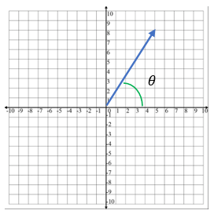

$$\vec{v}=\left\langle 5,\left.8\right\rangle \right.$$

$$θ=\tan^{-1}\frac{y}{x}$$

$$θ=\tan^{-1}\frac{8}{5}$$

Using a calculator, we get $θ=57.99°$ $θ=58°$

To approximate the direction of the vector $\vec{v}=\left\langle 5,\left.-8\right\rangle \right.$, use $θ=\tan^{-1}\frac{y}{x},$ with $x=5$ and $y=-8.$

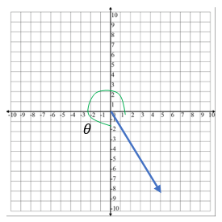

$$\vec{v}=\left\langle 5,\left.-8\right\rangle \right.$$

$$θ=\tan^{-1}\frac{y}{x}$$

$$θ=\tan^{-1}\frac{-8}{5}$$

Using a calculator, we get

$θ=-57.99°$

Vertical component is in Quadrant IV and $θ$ must be in the interval $\left[0,\left.360\right)\right.$, therefore we calculate $θ$ by

$θ=360°-57.99°=302.005°$

$θ=302°.$

## THE COMPONENTS OF A VECTOR

The lengths of the $x$- and $y$- components of a vector $\left\|\vec{v}\right\|=\sqrt{{v_{x}}^{2}+{v_{y}}^{2}}$

in two dimensions can be found using trigonometric ratios.

${\vec{v}}_{x}=\left\|\vec{v}\right\|cosθ$ and ${\vec{v}}_{y}=\left\|\vec{v}\right\|sinθ$

${\vec{v}}_{x}$ is the horizontal component of $\vec{v}$ and ${\vec{v}}_{y}$ is the vertical component.

The angle $θ$ is always between 0° and 360°.

Suppose the magnitude of a vector $\vec{v}=\left\langle v_{x},\left.v_{y}\right\rangle \right.$ is 20 units, and that $\vec{v}$ makes a 60° angle with the horizontal. Then, the components of $\vec{v}$ are

and

$${\vec{v}}_{x}=\left\|\vec{v}\right\|cosθ$$

$$=20cos60°$$

$$=20∙\frac{1}{2}$$

$$=10$$

$${\vec{v}}_{y}=\left\|\vec{v}\right\|sinθ$$

$$=20sin60°$$

$$=20∙\frac{\sqrt{3}}{2}$$

$$=10\sqrt{3}$$

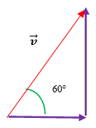

So, we could write $\vec{v}=\left\langle v_{x},\left.v_{y}\right\rangle \right.$ as $\vec{v}=\left\langle 10,\left.10\sqrt{3}\right\rangle \right.$

## USING TECHNOLOGY

We can use technology to determine the magnitude of a vector.

Go to www.wolframalpha.com.

To find the magnitude of the vector $\vec{v}=\left\langle 2,\left.4\right\rangle ,\right.$ enter magnitude of <2,4> in the entry field. Wolframalpha tells you what it thinks you entered, then tells you its answer. In this case, $\left\|\vec{v}\right\|=2\sqrt{5}$.

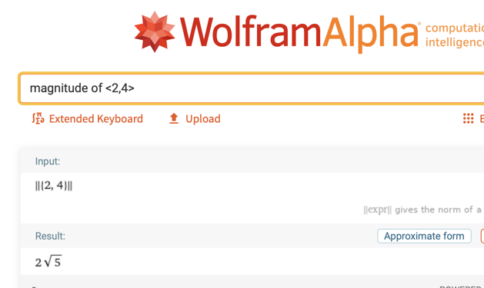

To find the direction of the vector $\vec{v}=\left\langle 5,\left.8\right\rangle ,\right.$ enter direction of the vector <5,8>in the entry field. Wolframalpha answers $57.9946°≈58°$.

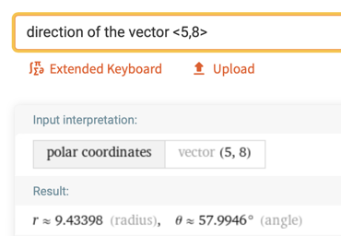

## EXAMPLES

1. Find the magnitude of the vector $\vec{v}=\left\langle 3,\left.-4\right\rangle \right..$

ANS: $\left\|\vec{v}\right\|=5$

1. Find the magnitude of the vector $\vec{v}=\left\langle -3,\left.-3\right\rangle \right..$

ANS: $\left\|\vec{v}\right\|=3\sqrt{2}$

1. Find the components of the vector $\vec{v}$ if the magnitude of $\vec{v}$ is 6 and it makes a 30° angle with the horizontal.

ANS: ${\vec{v}}_{x}= 3\sqrt{3}$ and ${\vec{v}}_{y}=3$

1. Approximate the direction of the vector $\vec{v}=\left\langle 3,\left.10\right\rangle \right.$.

ANS: $θ≈73.3008°$

## NOTE TO INSTRUCTOR

1. Remind students of the Pythagorean Theorem.

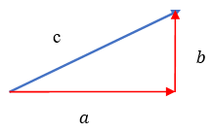

$$a^{2}+b^{2}=c^{2}$$

1. Consider deriving the magnitude of a vector $\vec{v}=\left\langle v_{x},\left.v_{y}\right\rangle \right.$ using the Pythagorean Theorem. Note that the $v_{x}$ and the $v_{y}$ in $\left\langle v_{x},\left.v_{y}\right\rangle \right.$ represent the lengths of the horizontal and vertical components, respectively, of .

|  |  |
| --- | --- |
|  | A diagram showing the magnitude of a vector and its horizontal and vertical components. |

Use as an example of the vector $\vec{v}=\left\langle 6,\left.3\right\rangle \right.$. The magnitude of $\vec{v}=\left\langle 6,\left.3\right\rangle \right.$ is

$$\left\|\vec{v}\right\|=\sqrt{{v_{x}}^{2}+{v_{y}}^{2}}$$

$$\left\|\vec{v}\right\|=\sqrt{6^{2}+3^{2}}$$

$$\left\|\vec{v}\right\|=\sqrt{36+9}$$

$$\left\|\vec{v}\right\|=\sqrt{45}$$

$$\left\|\vec{v}\right\|=\sqrt{9⋅5}$$

$$\left\|\vec{v}\right\|=\sqrt{9}⋅\sqrt{5}$$

$$\left\|\vec{v}\right\|=3\sqrt{5}$$

1. Demonstrate how to find the magnitude of $\vec{v}=\left\langle -5,\left.4\right\rangle \right.$.
$$\left\|\vec{v}\right\|=\sqrt{{v_{x}}^{2}+{v_{y}}^{2}}$$

$$\left\|\vec{v}\right\|=\sqrt{{(-5)}^{2}+4^{2}}$$

$$\left\|\vec{v}\right\|=\sqrt{25+16}$$

$$\left\|\vec{v}\right\|=\sqrt{41}$$

2. Find the components of the vector $\vec{v}$ if the magnitude of $\vec{v}$ is 7 and it makes a 30° angle with the horizontal.

$${\vec{v}}_{x}=\left\|\vec{v}\right\|cosθ$$

$$=7cos30°$$

$$=7∙\frac{\sqrt{3}}{2}$$

$$=\frac{7\sqrt{3}}{2}$$

$${\vec{v}}_{y}=\left\|\vec{v}\right\|sinθ$$

$$=7sin30°$$

$$=7∙\frac{1}{2}$$

$$=\frac{7}{2}$$

So, ${\vec{v}}_{x}= \frac{7\sqrt{3}}{2}$ and ${\vec{v}}_{y}=\frac{7}{2}$

1. Approximate the components of the vector $\vec{v}$ if the magnitude of $\vec{v}$ is 16 and it makes a 128° angle with the horizontal.

$${\vec{v}}_{x}=\left\|\vec{v}\right\|cosθ$$

$$=16cos128°$$

$$≈16∙(-0.616)$$

$$≈-9.86$$

$${\vec{v}}_{y}=\left\|\vec{v}\right\|sinθ$$

$$=16sin128°$$

$$≈16∙(0.788)$$

$$≈12.61$$

So, ${\vec{v}}_{x}= -9.86$ and ${\vec{v}}_{y}=12.61$

1. Approximate the direction of the vector $\vec{v}=\left\langle 2,\left.7\right\rangle \right.$.

$$θ=\tan^{-1}\frac{y}{x}$$

$$θ=\tan^{-1}\frac{7}{2}$$

Using a calculator, we get

[2-3_magnitude_direction_and_components_of_a_vector.docx](https://oer4cte.org/math4gamedevelopers/teacher/2-3_magnitude_direction_and_components_of_a_vector.docx), attributed to Denny Burzynski (author) and Downey Unified School District (publisher) is licensed under CC BY-NC 4.0. To view a copy of this license, visit https://creativecommons.org/licenses/by-nc/4.0